**ADS Project 2018-19 SEIT**

**Process Handling Using Heap Data Structure**

**The Code is Written in Java.**

**It has been run Using NetBeans IDE.**

**Written By:**

|  |  |  |
| --- | --- | --- |
| **Sr No.** | **Name** | **UID** |
| **1.** | **Manas Sinkar** | **2017140057** |
| **2.** | **Parth Thosani** | **2017140060** |
| **3.** | **Vinayak Iyer** | **2017120019** |

**To run the Program Follow the Instructions given below :-**

1. There are 2 Files MinHeap.java and adsproject.java in the same package named “Adsproj”.
2. Open the Project folder in NetBeans with these 2 files or on any other editor but keep both the files in a folder name as the same as the package name.
3. The main method is in file adsproject.java hence you need to compile and run the code in that file only.
4. And hence you will get the Output on the Console as Follows.

**The Functionality of the Code is mentioned below:**

1. You will be asked to enter initial number of jobs.
2. Then for the initial jobs you will have to enter non zero or non negative values that indicate time required for each job.(in our code 1 unit is 5 seconds)
3. Then the Heap is displayed, and then you will have to enter some job every 5 seconds as asked and press enter each time you enter some data(data>=0, if no job then enter 0).
4. The minimum value in the heap will be at the top as it is a minheap implementation because priority is shortest job first.
5. The Value at the top will decrease every 5 seconds by 1 to simulate the time taken by the process.
6. The Value you will enter at run time will be inserted in the heap and heapified so that if it has the highest priority it will be executed first.
7. Eventually depending on your input’s the heap will get empty and the code will terminate.

**Here are some screenshots of the output:**

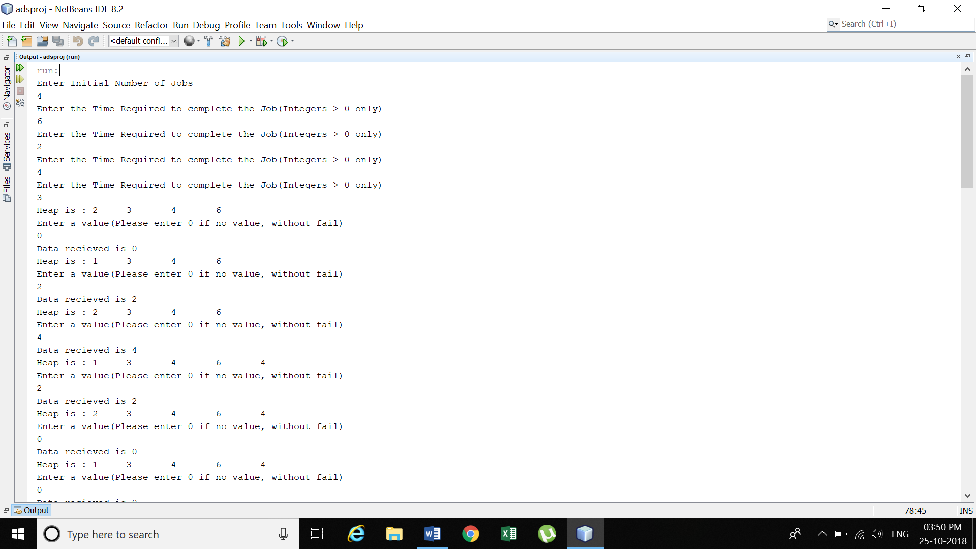

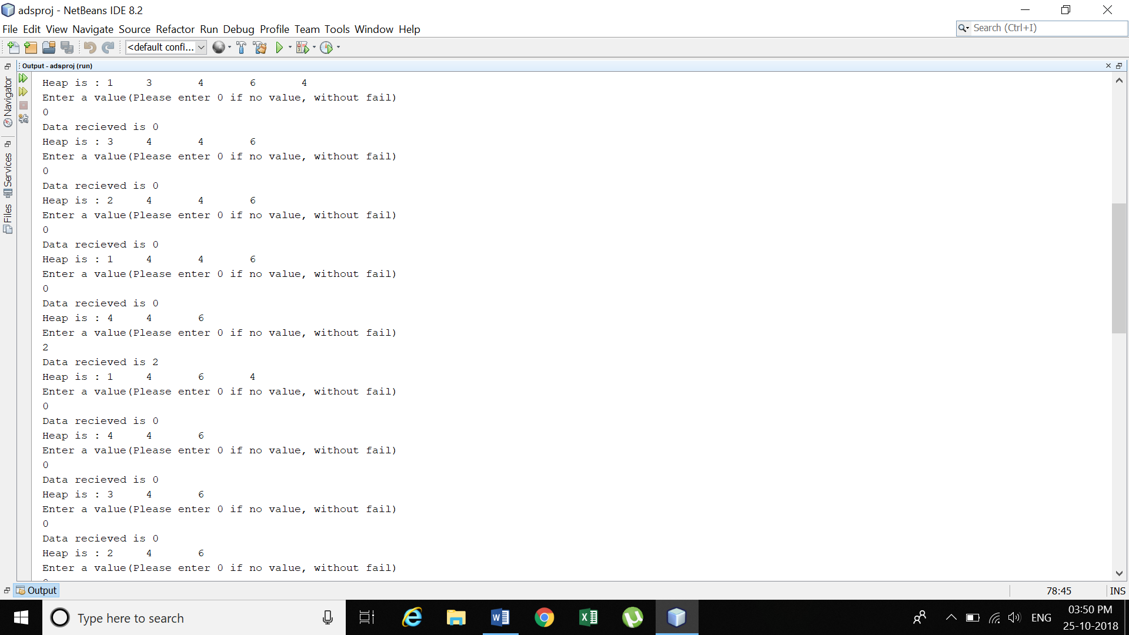

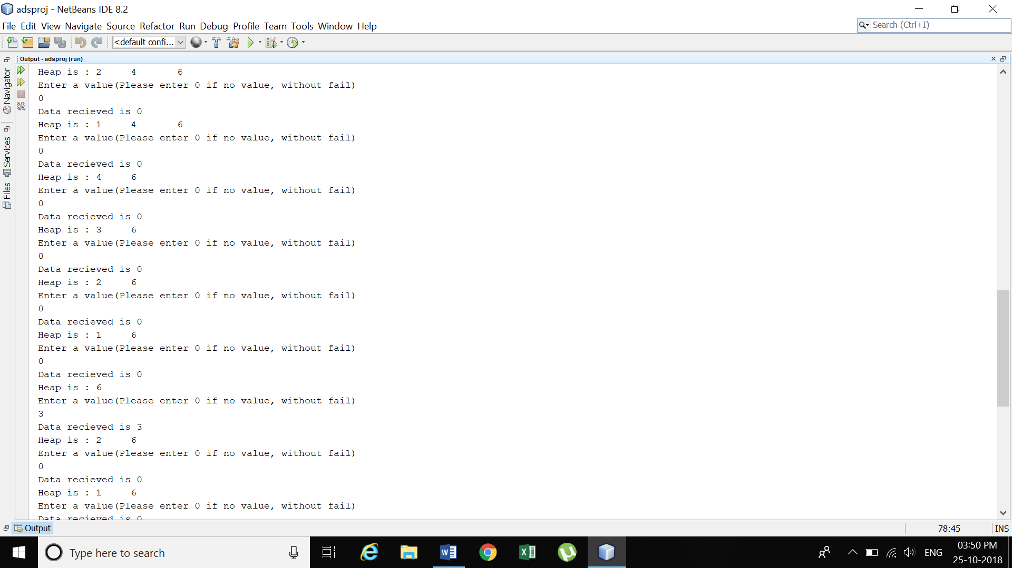

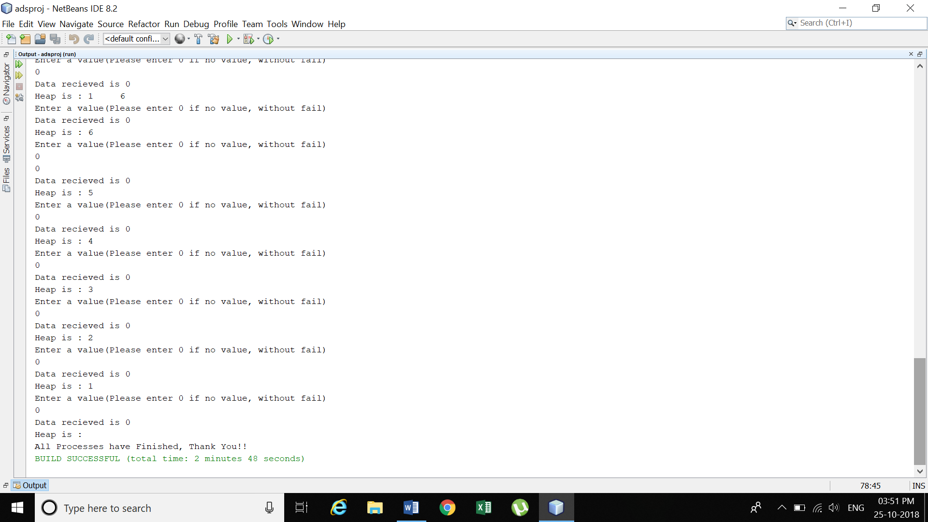

**Thank You!!**